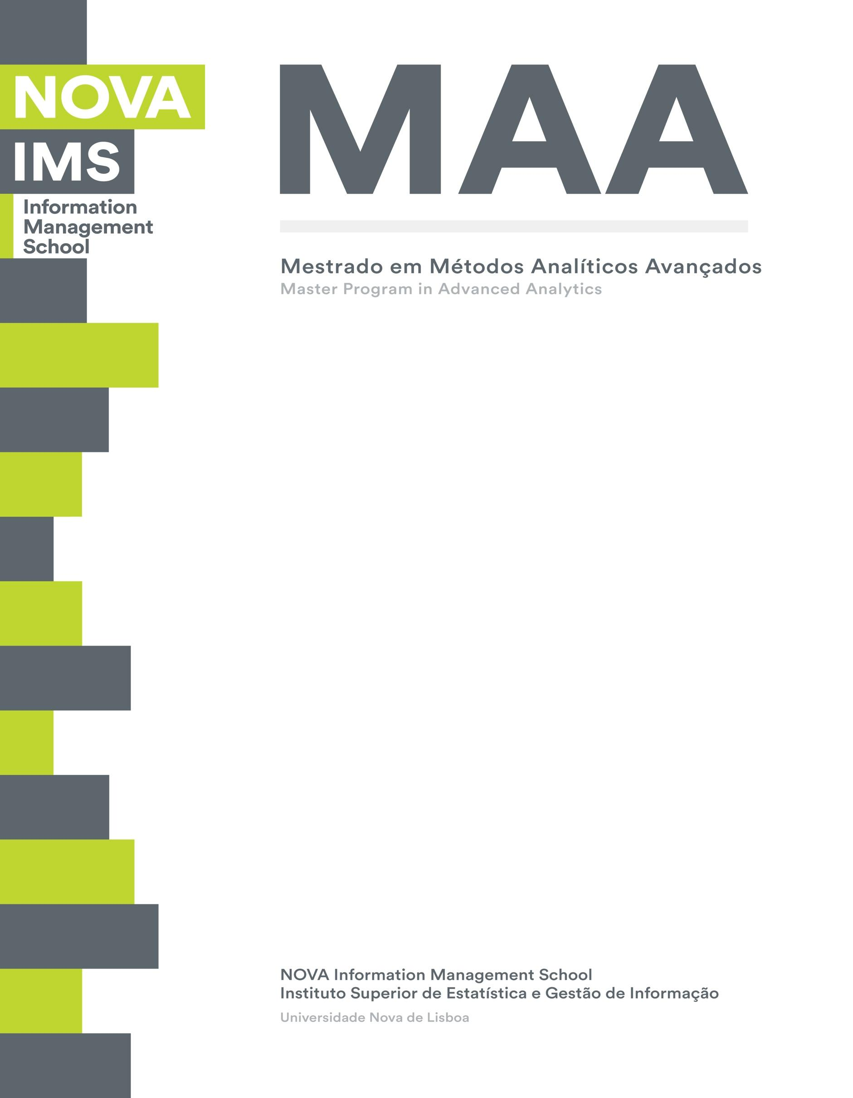

**Data Visualization Report**

**Visualizing Environmental, Economic and Educational and Depression indicators of Armenia, Bangladesh, Brazil & Portugal**



Group Members:

Ali Sabbir - M20190580

Lilit Tonoyan – M20190930

Eliane Maria Zanlorense – M20190802

Fernando Afonso Ribeiro – M20190815

# Motivation

In our Data Visualization group, we are from four different countries. In this perspective, most of the indicators are different for each other including culture, people, social behavior, development indicators and so on. From this point of view, we decided to compare datasets of four indicators to visualize the data using different types of visualization techniques, that we have learnt during the course.

As the Data is growing at an extraordinary rate, and it will keep growing in the foreseeable future. It is easy to present data in a pictorial or graphical format using different Data visualization techniques. Data visualization techniques are easier to understand for the people of different disciplines if the visualization technique is used properly according to the types of indicators. With interactive visualization, you can take the concept a step further by using technology to drill down into charts and graphs for more detail, interactively changing what data you see and how it is processed.

Below you can observe a connection map. This map allows to show the connection between several positions on a map. The link between 2 places can be drawn with a straight line, or more commonly by representing the ‘great circle‘: the shortest route between them. Knowing that the earth is a sphere, this results in rounded lines that give a really pleasant look to the map.

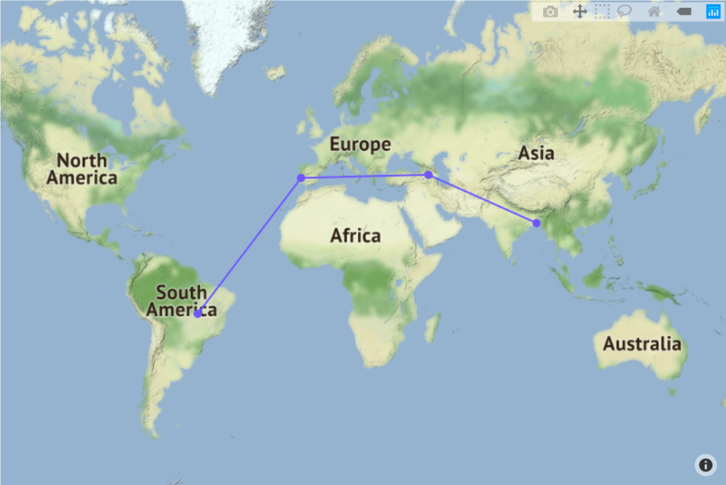

Overview

To get a generalized picture, we decided to take two datasets, **Population** and **GDP** **per capita** for our four countries. What characterizes the country better than the Population and Population Growth. We are comparing **Total Population** and **Population Growth** from 2005 to 2016 to get more accurate data. These variables are some kind of base for our further research and are responsible for correct perception of the data. The line graph below shows population growth for selected period. Line graphs are convenient to compare changes over the same period of time for more than one group. Each color represents one country.

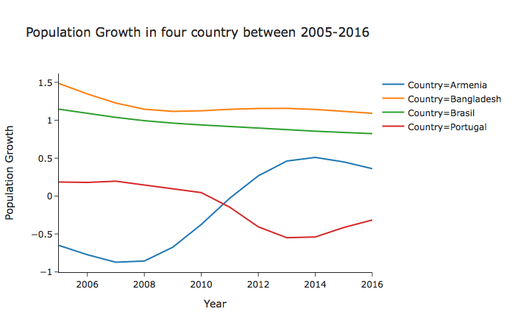

Next one is **GDP per capita,**  an indicator of a country's economic production and output that accounts for its number of people, which takes. This makes it a good measurement of a country's standard of living. It tells you how prosperous a country feels to each of its citizens. We have chosen this dataset to compare the GDP per capita because it will show us the difference of overall economic growth for four countries. We have not used Purchasing power parity (PPP) in line with GDP per capita which may tells us a story about the monetary capability of people of four countries.

For GDP per capit**a** depiction we chose barplot technique, because it is the best way to depict this data. On the x-axis we can observe the years that we picked and on the y-axis the amount of money for each country in a specific year.

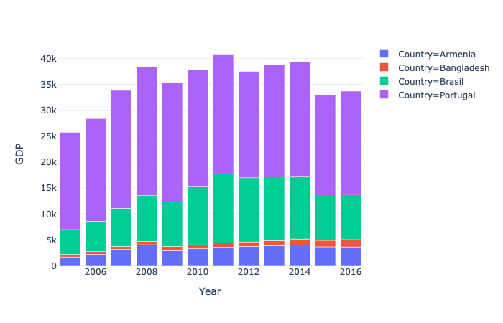

We have four countries with completely different sizes and **population**, so from a visualisation point of view it would be completely unsuitable to compare for instance Brasil and Armenia. After some observations it became obvious that despite its size Bangladesh’s population is easily comparable with Brasil’s. Тhe populations of Armenia and Portugal have approximately close parameters so we’ll visualize them together.

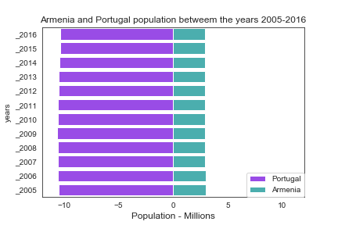

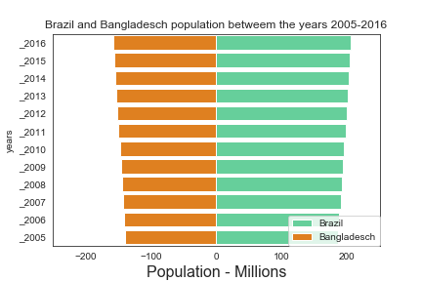

**Fertility rate**

The fertility rate in a specific year is defined as the number of children that would be born to each woman if she were to live to the end of her child-bearing years and give birth to children in alignment with prevailing age-specific fertility rates. Together with mortality and migration, fertility is an element of population growth, reflecting both the causes and effects of economic and social developments. This indicator is measured in children per woman. We used fertility rate to correlate it with the population and birth rate of four countries.  
For depiction we used line graph that has values on start and end points. It is commonly used to show a before and after of different values, based on comparing their values at different points in time.

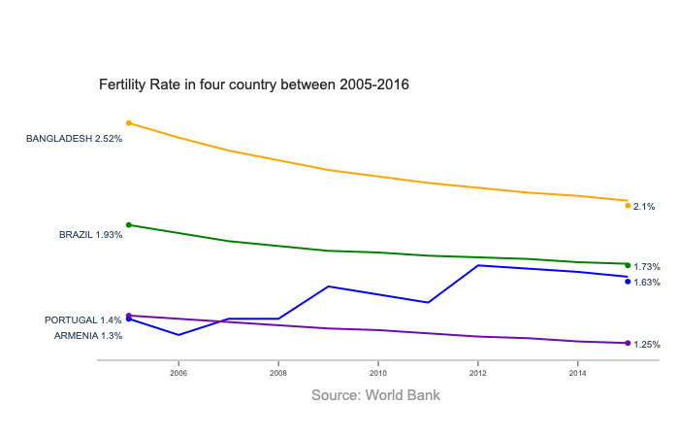

Indicators

For our visualization project we picked these variables :

**Alcohol and Drug Addiction**Here we have distilled and summarized tendencies, which are visualized in our entries on Substance Use and Alcohol Consumption which help us to understand the commonness of substance use disorders in the four countries. Understanding the true extent of substance use disorders has some correlation with the depression of respective countries.   
We have used a scatterplot to describe the story about the alcohol and drug addiction of the four countries. Here we are comparing multiple values and for each value of independent variable with a pair of numerical data.

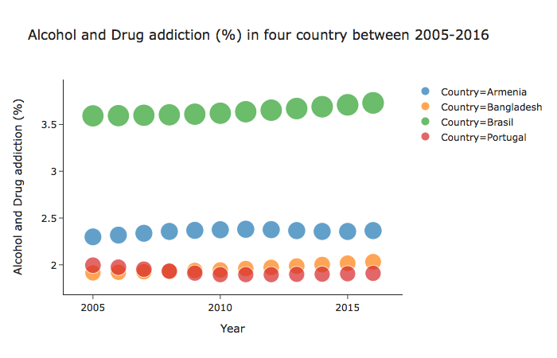

**Education Level**

Education is broadly recognized to be a vital parameter, for individuals, societies and as a whole for a country’s development index. Indeed, in most countries basic education is nowadays perceived not only as a right, but also as a duty – governments are typically expected to ensure access to basic education, while citizens are often required by law to attain education up to a certain basic level. But in our project we decided to compare only the tertiary education rate of four countries. Tertiary education is necessary for the discovery, proper dissemination and application of knowledge. Countries with better educated citizens are more equipped to deal with new challenges and technological advances. People with tertiary education find it easier to migrate from one country to another. The demand for highly-skilled workers is always high in developed countries. So we found this indicator to be crucial and comparing these values is a must. We presented our educational comparison using multi-faceted bar plot of our four countries, so that with the visualization it would be easy to clarify the variances.

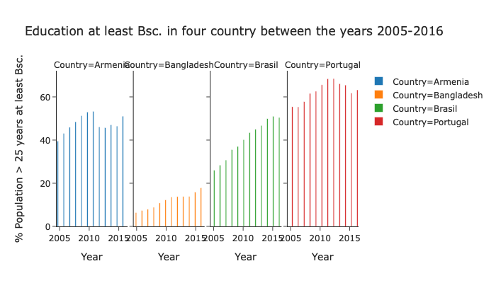

**CO2  Emissions**

The world’s countries emit vastly different amounts of heat-trapping gases into the atmosphere. CO2 data compiled by the International Energy Agency, which estimates carbon dioxide (CO2) emissions from the combustion of coal, natural gas, oil, and other fuels, including industrial waste and non-renewable municipal waste. However, developed nations typically have high carbon dioxide emissions per capita, while some developing countries lead in the growth rate of carbon dioxide emissions. We tried to figure out a simple comparison of co2 emission among four countries to associate the GDP and population. 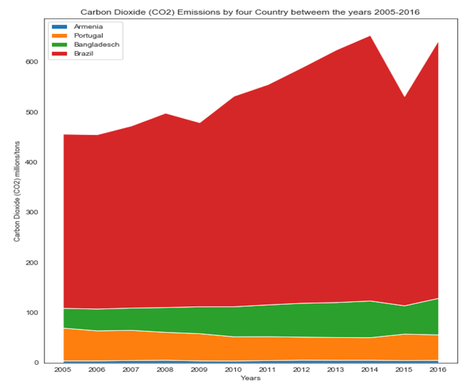

The Stacked Area Chart above is presenting the CO2 emissions of our four countries from 2005-2016. After looking at this graph it is not hard to understand that Brazil is the country with the highest amount of emissions. But this assumption may turn out to be misleading. On the line graph below it is visualized emission per capita to compare four country’s contribution in emission by the population of the respective countries at a glance to the Stacked Area Chart.

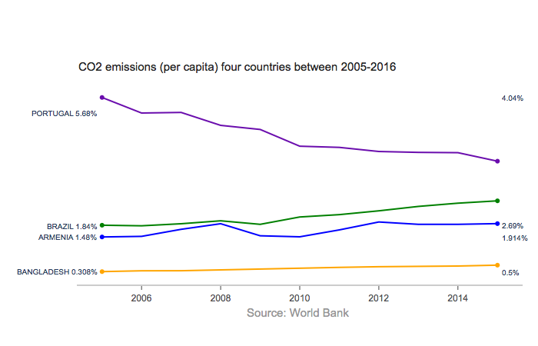

**Population with Depression**

In this entry we tried present the latest estimates of mental health disorder prevalence and the associated disease burden of four countries. Mental health disorders are complex and can take many forms. This data incorporates many forms, including depression, anxiety, bipolar, eating disorders and schizophrenia. Mental health disorders remain widely under-reported — in our section on Data Quality & Definitions we discuss the challenges of dealing with this data. This is true across all countries, but particularly at lower incomes where data is scarcer, and there is less attention and treatment for mental health disorders. Figures presented in this entry should be taken as estimates of mental health disorder prevalence — they do not reflect diagnosis data, but are imputed from a combination of medical, epidemiological data, surveys and meta-regression modelling where raw data is unavailable.

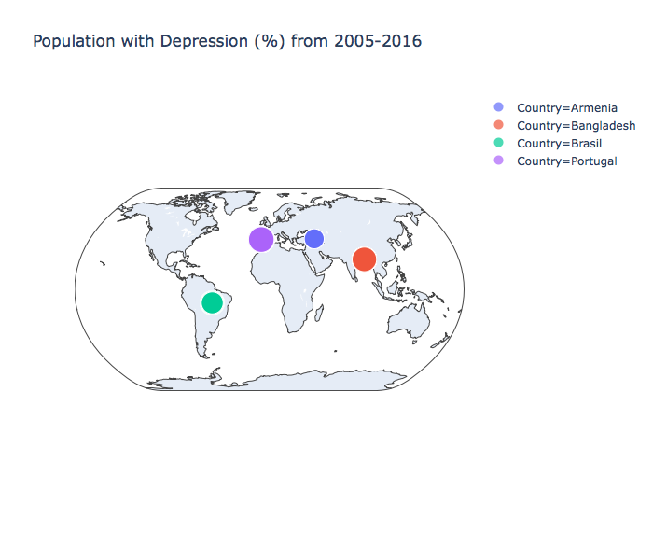

On this world map we can observe that despite the fact that countries have different cultures and traditions, we can say that on a percentage basis the level of depression in all countries is quite close. Especially Bangladesh and Portugal where the level is 4.4% and 4.1% respectively. Armenia has the lowest level only 2.7% and 3.3 % of Brazilian people are dealing with depression.

**Conclusion**  
After applying different types of visualization techniques dealing with three datasets, i.e Population, GDP and Fertility rate of Armenia, Bangladesh, Brazil and Portugal, we can realize the similarities and dissimilarities between the countries. Our countries are located in different continents, varying from South America, Europe, Central Asia and South Asia. We have expected some huge range of differences, when we were thinking about the project idea, because our culture and Social behavior are different. After using some visualization techniques, we have found that fertility rate of these countries are declining gradually, lowest is portugal 1.25% and highest is Bangladesh 2.1% in 2016. Depression level among the countries has no significant differences. Perhaps, exceptionally in total population Bangladesh and Brazil is way ahead than Armenia and Portugal. On the other perspective, the GDP per capita of these countries have substantial variance, for example in 2016 Portugal has $19,978 and lowest one is Bangladesh $1401. So, we can say that the living standard of people of these countries are highly varied. CO2 emission has correlation with the GDP per capita, our visualization clearly define the relation between the development and GDP. More GDP the county has, the more it emits CO2. In tertiary education, except Bangladesh rest of the countries are doing very good.

